HERO WEC LAMP Test Raw Data
This document describes the raw data sets generated during the 2026 HERO WEC LAMP test program and provides the information required to interpret these data sets. This document applies directly to the data contained in MHKDR 729 and may add useful context to the processed data contained in MHKDR 730. The data contained in MHKDR 729 is in the format of Technical Data Management Streaming (TDMS) files. Raw data from these files can be read using a TDMS viewer software such as Scout or Microsoft Excel add-ins. MHKDR 730 should be used for processed data in the form of parquet files, which can be read using Matlab or Python.
Run Log Overview
The run log document provides a complete list of test cases in this data set as well as additional information on individual cases. Each run has a unique name in the form of XX_XX_XD_000H_00T. The run names can be decoded using the information in Table 1. It should be noted that the “wave height” and “period” used in this test program are the significant wave height and peak wave period of the motion profile which is prescribed to LAMP for each test case and the test cases therefore do not represent the hydrodynamic response of the WEC in a given sea state.
Table 1: Test naming convention.
XX |  | XX |  | XD |  | 000H | 00T | 00
Configuration |  | Wave Type |  | Degrees of Freedom |  | Height | Period | Repeated Case
DT | Drivetrain | SI | Sine wave | 1D | Heave only | Wave height in sine wave cases and significant wave height in irregular wave cases. Both are specified in cm | Wave period in sine wave cases and peak wave period in irregular wave periods. Both are specified in seconds | Identifier used in the event that a test case was repeated. See run log for details on repeated cases.
HB | Hydraulic with RO bypassed | IR | Irregular (Pierson-Moskowitz)
HR | Hydraulic with RO | IR | Irregular (Pierson-Moskowitz) | 2D | Heave and surge
ED | Electric with power electronics disconnected
EC | Electric with power electronics connected

Raw Data Overview
Raw data from each test run of the HERO WEC V2 can be found in the form of sorted TDMS files. TDMS files are a proprietary data format by NI and are the output measurement files from the HERO WEC Modular Open-Source Data Acquisition (MODAQ) and NLR Ethercat Data Acquisition System (EDAS). Each folder contains files from one test run. Within each folder is a subfolder for each DAQ measurement group containing all TDMS files recorded by that DAQ measurement group during the test run. A description of the sensor groups and TDMS file folders can be found in Table 2.

Table 2: TDMS Subfolders/measurement groups.
Subfolder Name | Description | Sampling Frequency [Hz]
Buoy 10Hz | On-buoy sensors measured using EDAS | 10
Buoy 100Hz | On-buoy sensors measured using EDAS | 100
CurrentAI | Onshore 4-20mA sensors measured using MODAQ | 10
PowRaw | Generator output (electric configuration only) measured using MODAQ | 3000
VoltageAI | Onshore 0-10V sensors measured using MODAQ | 2000

Due to file storage concerns, each measurement group (except for the 100Hz buoy group data) saves a TDMS file every ten minutes, limiting the maximum file size. 100Hz buoy group data is saved to a TDMS file every minute by EDAS.
A detailed list of the sensors contained in each measurement group can be found in the following section, while system diagrams indicating the location of each sensor can be found in the appendix.
Measured Data Arrays
The raw data files contain measured data arrays from 35 sensors as well as time arrays for each sensor group. Both MODAQ and EDAS apply slopes and offsets to the measured current or voltage output from each sensor and all data arrays in the raw TDMS files and processed parquet files are in the engineering units associated with the measurement. Information on the measured data arrays contained in the raw TDMS and processed parquet files can be found in Table 3. The listed arrays contain data from each sensor used during testing; additional arrays present in the raw TDMS files should be disregarded.
Table 3: Measured Data Arrays
Sensor Group | Array Name | Description | Configuration | Units
Buoy (Both 10Hz and 100Hz) | MS_Excel_Timestamp | GPS synchronized EDAS timestamp (Excel format) | All | Days
Buoy (Both 10Hz and 100Hz) | LabVIEW_Timestamp | GPS synchronized EDAS timestamp (LabView format) | All | Seconds
Buoy (Both 10Hz and 100Hz) | PRESS_OS_1001 | Pump output pressure | Hydraulic | psi
Buoy (Both 10Hz and 100Hz) | PRESS_OS_2001 | Spring return air tank pressure | All | psi
Buoy (Both 10Hz and 100Hz) | PRESS_OS_2002 | Spring return vent tank pressure | All | psi
Buoy (Both 10Hz and 100Hz) | LAMP_DAS_Trigger_Sig | LAMP motion profile trigger signal | All | V
Buoy (Both 10Hz and 100Hz) | POS_OS_1001 | Winch position | All | Degrees
Buoy (Both 10Hz and 100Hz) | FLOW_OS_1001 | Pump outlet flow rate | Hydraulic | gpm
Buoy (Both 10Hz and 100Hz) | NLR_Load_Cell | Mooring line tension | All | lbf
CurrentAI | Time_DAQmx | GPS synchronized MODAQ timestamp | Hydraulic, Electric | ns (unix)
CurrentAI | Time_PTP | GPS synchronized MODAQ timestamp | Hydraulic, Electric | ns (unix)
CurrentAI | FLOW_ON_1001 | RO subsystem inlet flow rate | Hydraulic, Electric | gpm
CurrentAI | FLOW_ON_1002 | Clark pump inlet flow rate | Hydraulic, Electric | gpm
CurrentAI | FLOW_ON_1003 | Brine discharge flow rate | Hydraulic, Electric | gpm
CurrentAI | FLOW_ON_1004 | Permeate flow rate | Hydraulic, Electric | gpm
CurrentAI | CND_ON_1001 | RO inlet conductivity (do not use) | Hydraulic, Electric | micro-Siemens
CurrentAI | CND_ON_1002 | Permeate conductivity | Hydraulic, Electric | micro-Siemens
VoltageAI | Time_DAQmx | GPS synchronized MODAQ timestamp | Hydraulic, Electric | ns (unix)
VoltageAI | Time_PTP | GPS synchronized MODAQ timestamp | Hydraulic, Electric | ns (unix)
VoltageAI | PRESS_ON_1001 | RO subsystem inlet pressure | Hydraulic, Electric | psi
VoltageAI | PRESS_ON_1002 | Clark pump inlet pressure | Hydraulic, Electric | psi
VoltageAI | PT_ON_2001 | Rectifier output voltage | Electric | V
VoltageAI | CT_ON_2001 | Rectifier output current | Electric | A
VoltageAI | PT_ON_2002 | Charge controller input voltage | Electric | V
VoltageAI | CT_ON_2002 | Charge controller input voltage | Electric | A
VoltageAI | PT_ON_2003 | Charge controller output voltage | Electric | V
VoltageAI | CT_ON_2003 | Charge controller output current | Electric | A
VoltageAI | PT_ON_2004 | Battery voltage | Electric | V
VoltageAI | CT_ON_2004 | Battery input current | Electric | A
VoltageAI | PT_ON_2005 | Pump controller input voltage | Electric | V
VoltageAI | CT_ON_2005 | Pump controller input current | Electric | A
VoltageAI | PT_ON_2006 | Pump 1 voltage | Electric | V
VoltageAI | CT_ON_2006 | Pump 1 current | Electric | A
VoltageAI | PT_ON_2007 | Pump 2 voltage | Electric | V
VoltageAI | CT_ON_2007 | Pump 2 current | Electric | A
PowRaw | Time_DAQmx | GPS synchronized MODAQ timestamp | Electric | ns (unix)
PowRaw | Time_PTP | GPS synchronized MODAQ timestamp | Electric | ns (unix)
PowRaw | PT_ON_1001 | Phase A to phase C AC voltage measurement. | Electric | V
PowRaw | CT_ON_1001 | Generator phase A current | Electric | A
PowRaw | PT_ON_1002 | Phase A to phase B AC voltage measurement. | Electric | V
PowRaw | CT_ON_1002 | Generator phase B current | Electric | A
PowRaw | PT_ON_1003 | Phase B to phase C AC voltage measurement. | Electric | V
PowRaw | CT_ON_1003 | Generator phase C current | Electric | A

Hydraulic System Modifications During Testing
The HERO WEC V2 was designed to use the Comet BP125K diaphragm pump in the hydraulic configuration. During testing, the outlet check valves in this pump were found to have failed and were replaced with an equivalent set of spare check valves, which later failed too. Following these failures, the original outlet manifold was removed, and a custom plumbing system was installed, allowing the use of Bonomi S250 check valves as a replacement for the original valves. The S250 valve bodies later failed, and these were later replaced with Bonomi S800 check valves. Shortly after installing the S800 valves, the Teflon valve seat in these components was found to have failed. Following this failure, the Teflon valve seat was removed and testing resumed. Information on which check valves were used during each individual LAMP test can be found in the run log. Run ID 10 and 45 show reduced pump efficiency due to known valve failures. When operational, no significant performance differences were observed between the different valves.
Known Instrumentation Issues
During testing, multiple instrumentation issues were found which affect the recorded data. FLOW-ON-1004 was found to be configured using an incorrect measurement range setting, resulting in measured values which must be divided by 5 to get the correct value. This sensor was initially configured for a range of 0-6.6 gpm and was reset to 0-1.32 gpm at the end of the day on June 9, 2026. This issue affected data sets recorded before this time (run ID numbers 4-10) and the correction has been applied to this data array in the processed parquet files where needed.
The set screw securing the shaft of the POS-OS-1001 encoder to the primary shaft was found to have loosened, allowing the encoder to slip relative to the primary shaft. This issue affects data sets recorded on or after July 20, 2026 (run ID numbers 29-59). As a result, the position and velocity data in the affected data sets may not accurately represent the motion of the primary shaft and should not be considered reliable.
At approximately 11:00 a.m. on July 28, 2026, the LAMP trigger signal stopped working. This issue was resolved at the end of the day on July 29, 2026 (affects run ID numbers 37-42). All processed data sets for test cases run during this time were manually trimmed and may have small variances in the length of the data set.
CND-ON-1001 had significant corrosion from previous testing. The sensor was not repaired or replaced and the recorded measurement is known to be unreliable throughout the entire test program. Due to the lack of this measurement, a handheld conductivity meter was used to measure salinity before testing each day. These values can be found in the run log.
PT-ON-1001, PT-ON-1002, and PT-ON-1003 were found to have an incorrect slope applied in the MODAQ system to convert the sensor output signal to the measured AC voltage value. The original slope applied to these sensors was calculated assuming that the sensor output a -10 to +10 V signal. The sensor was later found to output a signal of -7 to +7 volts when used for AC measurements. This has been corrected in the processed data sets by multiplying the recorded value by 7/10.

Example
The following is an example of how to use Scout to visualize the RO inlet flow measurement (FLOW-ON-1001) from a hydraulic configuration irregular wave of a 0.25m height and 6 second peak period.
- First select a test run of interest from the run log document.
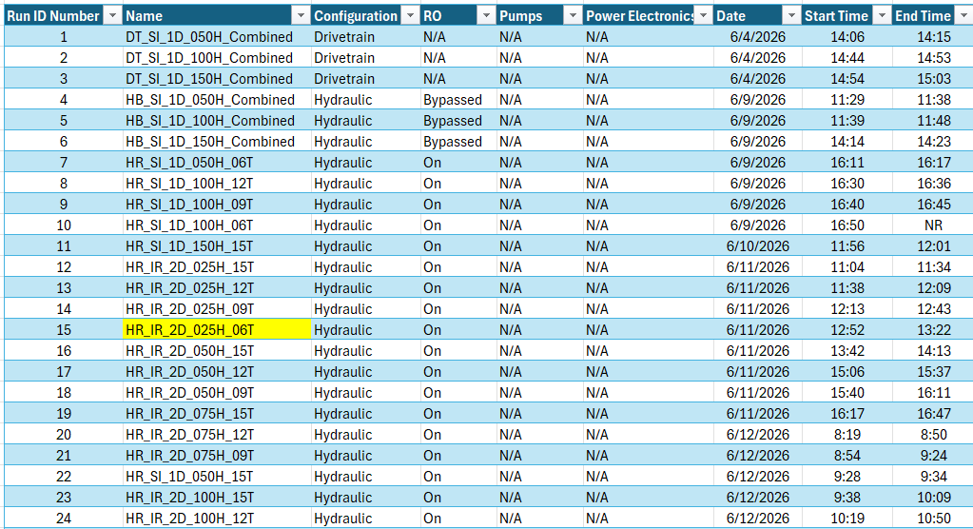

- After selecting a test case, navigate to the downloaded folder of test cases for the PTO configuration (drivetrain, hydraulic, or electric) of the selected test case and find the top-level data folder for the selected test case.
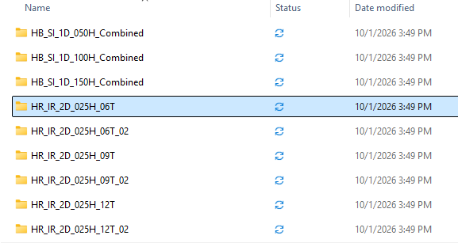

- Open the top-level data folder for the selected test case and identify the sensor group for the measurement(s) of interest using Table 3.
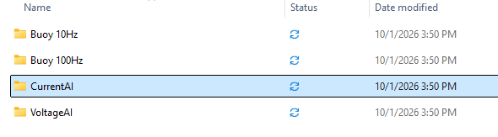

- Open the sensor group data folder for the selected test case and select a data file. Note: due to file size concerns, 100Hz buoy data is saved to a TDMS file every minute and data from all other sensor groups is saved to a TDMS file every ten minutes. A typical test case contains multiple data files for each sensor group.
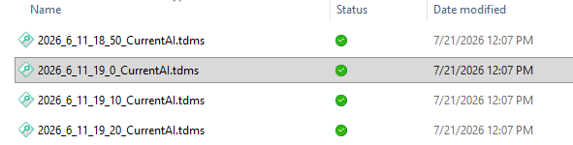

- Open the selected data file using either Scout or a Microsoft Excel TDMS reader. Note: the image below shows data plotted in Scout. If a Microsoft Excel TDMS reader is used, follow instructions specific to the Excel add in.
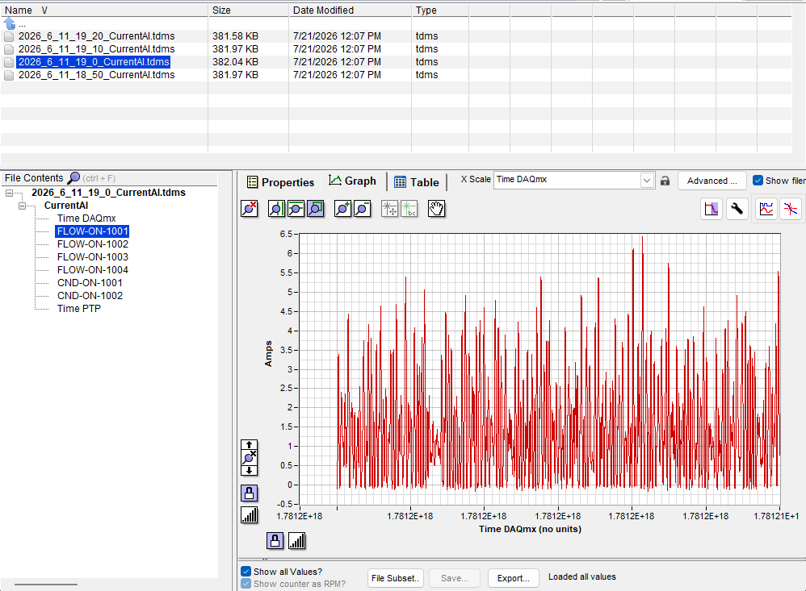
Appendix
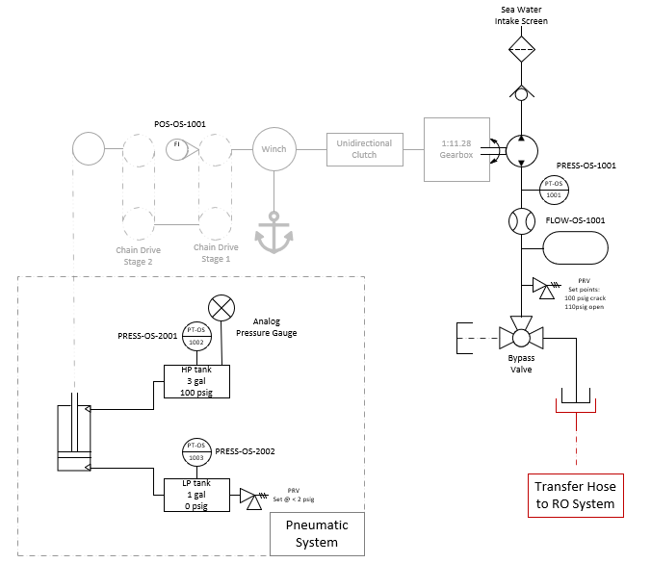
Figure 1: Location of on buoy sensors.
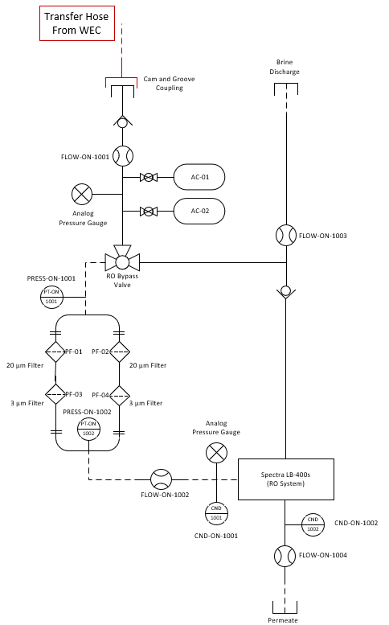
Figure 2: Location of RO system sensors.
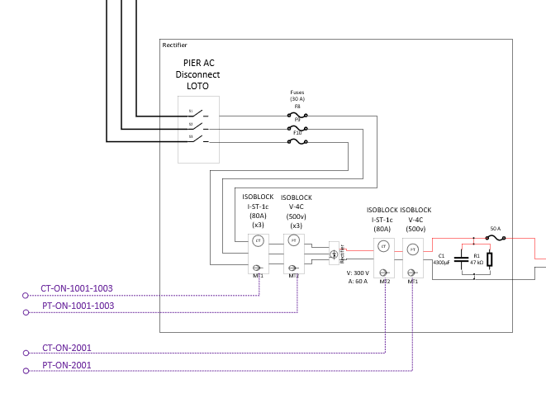
Figure 3: Location of PT and CT sensors used to measure three phase AC electricity from generator and DC electricity after rectifier.
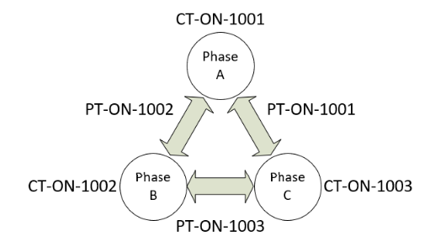
Figure 4: Line to line AC measurement diagram.
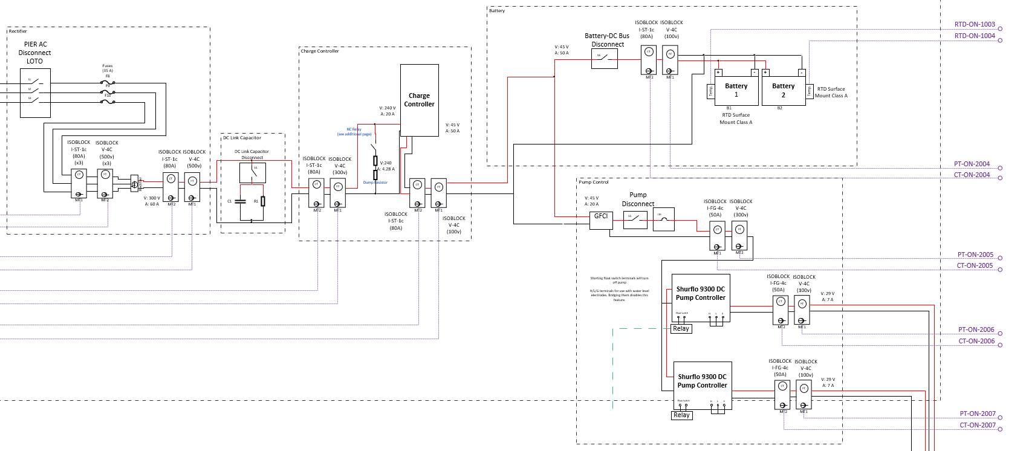
Figure 5: Location of PT and CT sensors after rectifier.

